iStudio
Name: Ayush Kumar
Assignment number: 2
Course / Internship name: Data Analytics Internship
Problem Statement
In modern retail and e-commerce, businesses generate vast amounts of raw data across customer demographics and transaction histories. Understanding customer behavior, regional demand, and spending trends is critical for optimizing marketing strategies, product stock, and revenue growth.
Core Problem
The organization faces challenges in deriving actionable insights from raw, uncleaned operational data. Specifically, customer records contain missing information (such as missing age and gender fields), and sales transactions are recorded in separate datasets. Without structured data cleaning, integration, and quantitative analysis, the business cannot accurately answer fundamental performance questions:
- Demographic & Geographic Insights: Which cities and customer segments generate the highest sales revenue?
- Purchasing Trends: Who are the top-spending customers, and what purchasing frequency do they exhibit?
- Temporal Dynamics: How do product sales fluctuate over time across different product categories?
- Sales Growth: What is the month-over-month growth trajectory of retail store sales?
Code:
import matplotlib.pyplot as plt
import numpy as np
import pandas as pd
import seaborn as sns

sns.set_theme(style="whitegrid")
print("Libraries loaded successfully!")

Task 1:
Python data types + arithmetic / comparison / logical operator program output, and NumPy operations output for the 12-month sales data.
# ==========================================
# TASK 1.1: PYTHON BASICS
# ==========================================
print("=== TASK 1.1: PYTHON BASICS ===")
# Declare variables of required data types
i = 25
f = 3.14
s = "Data Analytics"
b = True
lst = [10, 20, 30]
tup = (1, 2, 3)
dct = {"name": "Aarav", "age": 28}
# Print values and their respective types
print("i:", i, type(i))
print("f:", f, type(f))
print("s:", s, type(s))
print("b:", b, type(b))
print("lst:", lst, type(lst))
print("tup:", tup, type(tup))
print("dct:", dct, type(dct))
print("-" * 40)
# Arithmetic Operators
a, b_num = 10, 3
print("Arithmetic Operators (10 and 3):")
print("Add (+):", a + b_num)
print("Sub (-):", a - b_num)
print("Mul (*):", a * b_num)
print("Div (/):", a / b_num)
print("Mod (%):", a % b_num)
print("Power (**):", a**b_num)
print("Floor Div (//):", a // b_num)
print("-" * 40)
# Comparison & Logical Operators
print("Comparison Operators:")
print("a == b_num:", a == b_num)
print("a > b_num:", a > b_num)
print("a < b_num:", a < b_num)
print("\nLogical Operators:")
print("(a > 5) and (b_num < 5):", (a > 5) and (b_num < 5))
print("(a == 5) or (b_num == 3):", (a == 5) or (b_num == 3))
# ==========================================
# TASK 1.2: NUMPY OPERATIONS
# ==========================================
print("\n=== TASK 1.2: NUMPY OPERATIONS ===")
# Create NumPy array for 12 months sales
sales = np.array([125, 138, 142, 155, 168, 180, 195, 210, 225, 240, 258, 275])
# Print array properties & statistics
print("Shape:", sales.shape)
print("Size:", sales.size)
print("Dtype:", sales.dtype)
print("Sum:", sales.sum())
print("Mean:", sales.mean())
print("Max:", sales.max())
print("Min:", sales.min())
print("Std Dev:", round(sales.std(), 2))

# Reshape to 4x3 array
reshaped = sales.reshape(4, 3)
print("\nReshaped Array (4 rows x 3 columns):\n", reshaped)
# Find indices where sales > 200
high_sales_idx = np.where(sales > 200)[0]
print("\nMonth indices where sales > 200:", high_sales_idx)
# Calculate Month-over-Month growth
growth = np.diff(sales)
print("Month-over-Month Growth:", growth)
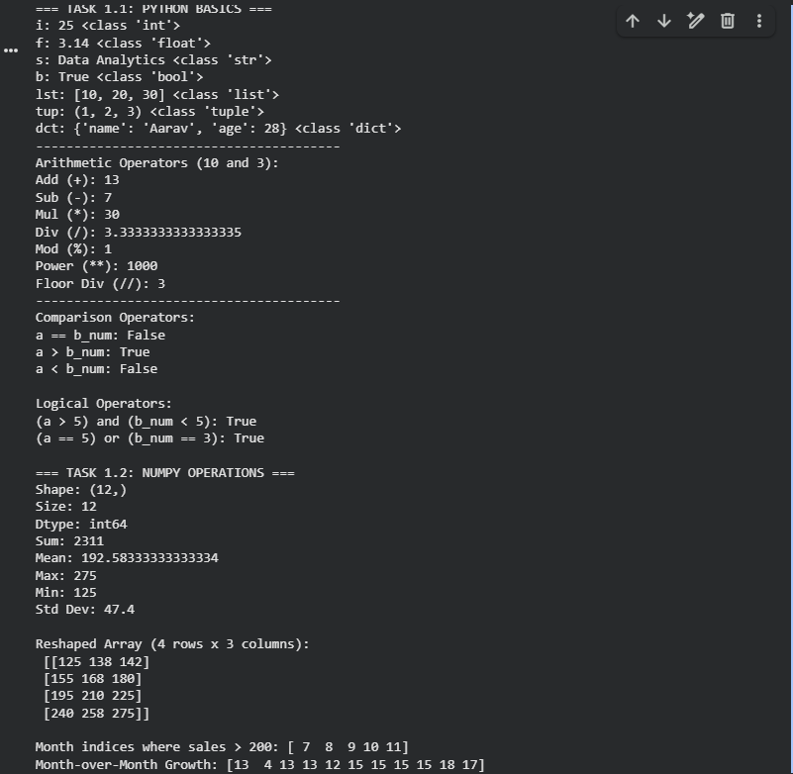
Task 2:
Customers and Purchases DataFrames loaded, cleaned (missing values handled), and successfully merged. Submit code and screenshots.
# ==========================================
# TASK 2: PANDAS - LOADING, CLEANING & MERGING
# ==========================================
# 2.1 Load Datasets
customers_data = {
'cust_id': ['C01', 'C02', 'C03', 'C04', 'C05', 'C06', 'C07', 'C08'],
'name': [
'Aarav',
'Bhavya',
'Chirag',
'Diya',
'Eshan',
'Farah',
'Gaurav',
'Hina',
],
'city': [
'Mumbai',
'Delhi',
'Bangalore',
'Mumbai',
'Pune',
'Delhi',
'Bangalore',
'Mumbai',
],
'age': [28, 32, 26, np.nan, 30, 29, 40, 27],
'gender': ['M', 'F', 'M', 'F', 'M', 'F', 'M', np.nan],
}
purchases_data = {
'purchase_id': [
'P101',
'P102',
'P103',
'P104',
'P105',
'P106',
'P107',
'P108',
'P109',
'P110',
],
'cust_id': [
'C01',
'C02',
'C03',
'C01',
'C05',
'C02',
'C06',
'C07',
'C03',
'C05',
],
'product': [
'Laptop',
'Saree',
'Smartphone',
'Tablet',
'Headphones',
'Watch',
'T-shirt',
'Backpack',
'Mouse',
'Charger',
],
'amount': [55000, 4500, 32000, 18000, 1500, 3500, 499, 1800, 899, 650],
'purchase_date': [
'2025-02-03',
'2025-02-05',
'2025-02-09',
'2025-02-11',
'2025-02-12',
'2025-02-14',
'2025-02-18',
'2025-02-20',
'2025-02-22',
'2025-02-26',
],
}
customers_df = pd.DataFrame(customers_data)
purchases_df = pd.DataFrame(purchases_data)
print("--- Customers DataFrame Head ---")
print(customers_df.head())
print("\n--- Purchases DataFrame Head ---")
print(purchases_df.head())
print("\n--- Customers Info ---")
customers_df.info()
# 2.2 Data Cleaning
print("\nMissing values in Customers:")
print(customers_df.isnull().sum())
# Fill missing age with mean age and convert to integer
mean_age = customers_df['age'].mean()
customers_df['age'] = customers_df['age'].fillna(mean_age).astype(int)
# Fill missing gender with 'Unknown'
customers_df['gender'] = customers_df['gender'].fillna('Unknown')
# 2.3 Data Merging
merged_df = pd.merge(customers_df, purchases_df, on='cust_id', how='inner')
merged_df['purchase_date'] = pd.to_datetime(merged_df['purchase_date'])
print("\n--- Cleaned & Merged DataFrame Head ---")
print(merged_df.head())
print("Merged DataFrame Shape:", merged_df.shape)
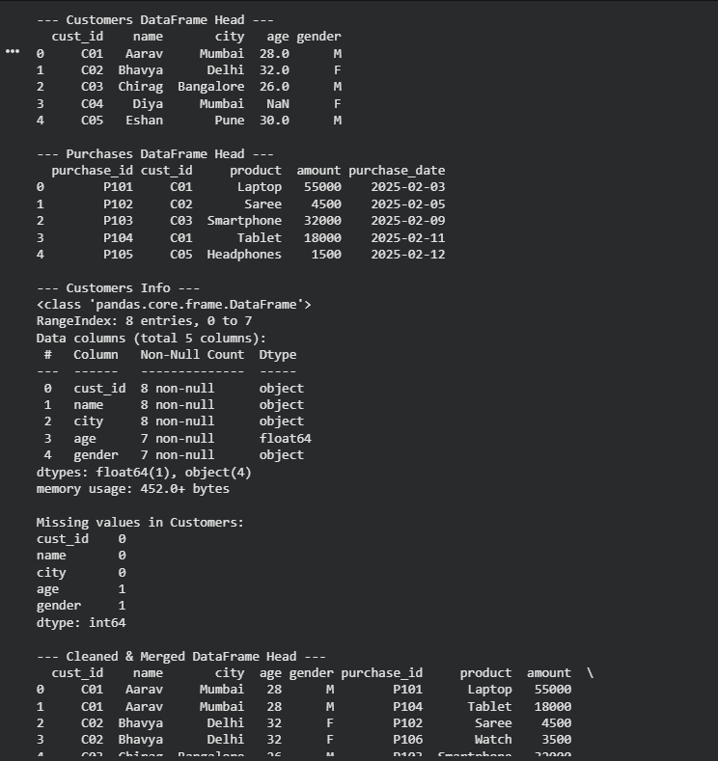
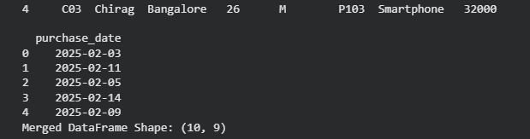
Task 3:
Filtering queries, groupby aggregations (4 outputs), 4 visualizations, and a 100-to-150-word conclusion paragraph.
# ==========================================
# TASK 3.1: FILTERING
# ==========================================
print("=== TASK 3.1: FILTERING ===")
print("1. Purchases from Mumbai:")
print(merged_df[merged_df['city'] == 'Mumbai'])
print("\n2. Purchases with amount > 5000:")
print(merged_df[merged_df['amount'] > 5000])

print("\n3. Male customers who made purchases:")
print(merged_df[merged_df['gender'] == 'M'])
# ==========================================
# TASK 3.2: GROUPING & AGGREGATION
# ==========================================
print("\n=== TASK 3.2: GROUPING & AGGREGATION ===")
# Total purchase amount per city
print("Total Purchase Amount per City:")
print(merged_df.groupby('city')['amount'].sum())
# Average purchase amount per gender
print("\nAverage Purchase Amount per Gender:")
print(merged_df.groupby('gender')['amount'].mean())
# Number of purchases per customer
print("\nNumber of Purchases per Customer:")
print(merged_df.groupby('cust_id').size())
# Top 3 customers by total spending
print("\nTop 3 Customers by Total Spending:")
top3 = (
merged_df.groupby('name')['amount']
.sum()
.sort_values(ascending=False)
.head(3)
)
print(top3)
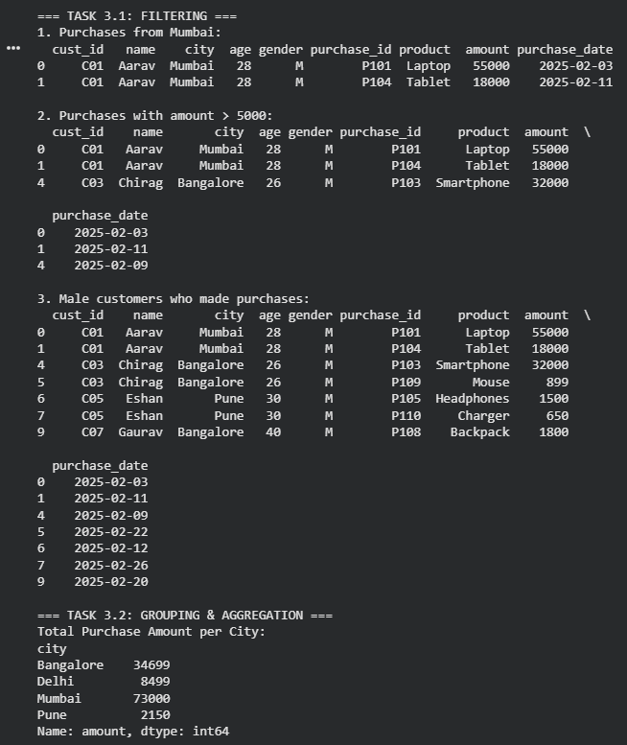

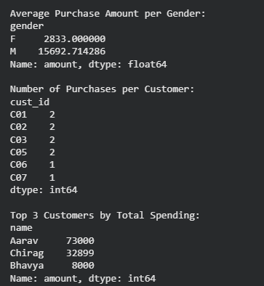
# ==========================================
# TASK 3.3: DATA VISUALIZATION
# ==========================================
# Plot 1: Bar Chart - Total purchase amount per city
plt.figure(figsize=(7, 4))
city_totals = merged_df.groupby('city')['amount'].sum()
city_totals.plot(kind='bar', color='steelblue')
plt.title('Total Purchase Amount by City', fontsize=12, fontweight='bold')
plt.xlabel('City', fontsize=10)
plt.ylabel('Total Amount (INR)', fontsize=10)
plt.xticks(rotation=0)
plt.tight_layout()
plt.show()
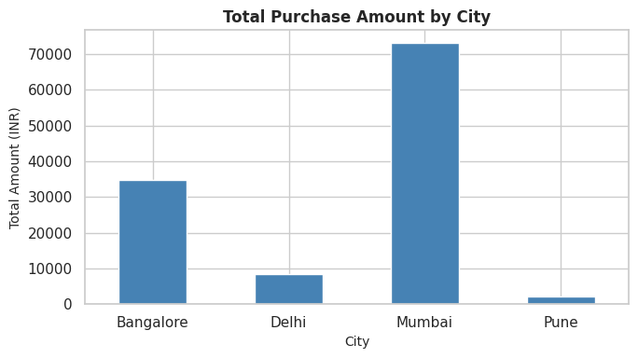
# Average Order Value (AOV) by City Plot (Plot 2)
plt.figure(figsize=(7, 4))
# Convert Series to DataFrame for explicit x, y, and hue mapping
city_avg_df = city_avg.reset_index()
city_avg_df.columns = ['city', 'amount']
sns.barplot(
data=city_avg_df,
x='city',
y='amount',
hue='city',
palette='Purples_r'
)
plt.legend([], frameon=False) # Removes redundant legend
plt.title('Average Order Value (AOV) by City', fontweight='bold')
plt.xlabel('City')
plt.ylabel('Average Amount (INR)')
plt.tight_layout()
plt.show()
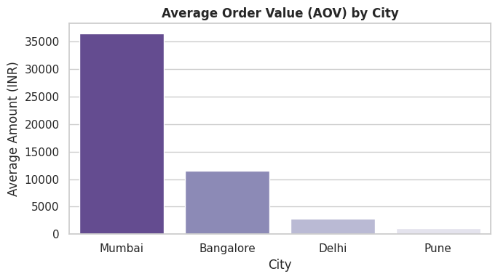
# Plot 3: Pie Chart - Share of purchases by gender
plt.figure(figsize=(6, 6))
gender_totals = merged_df.groupby('gender')['amount'].sum()
plt.pie(
gender_totals,
labels=gender_totals.index,
autopct='%1.1f%%',
colors=['#ff9999', '#66b3ff'],
startangle=90,
)
plt.title('Share of Purchase Amount by Gender', fontsize=12, fontweight='bold')
plt.tight_layout()
plt.show()
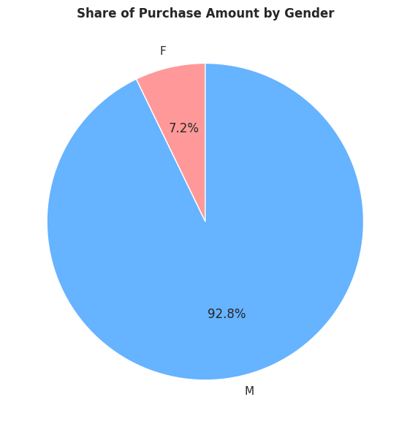
# Revenue by Product Category (Plot 4)
plt.figure(figsize=(7, 4))
prod_sales = (
merged_df.groupby('product')['amount'].sum().sort_values(ascending=True)
)
prod_sales.plot(kind='barh', color='mediumseagreen')
plt.title('Revenue Generation by Product Category', fontweight='bold')
plt.xlabel('Total Revenue (INR)')
plt.ylabel('Product Category')
plt.tight_layout()
plt.show()
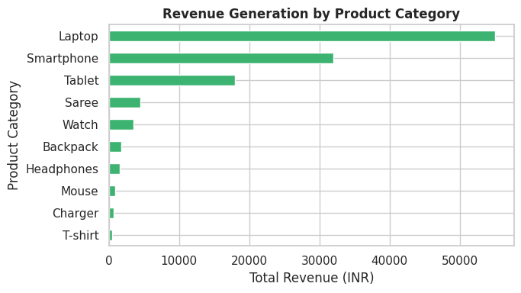
# Bar Chart (Plot 5)
plt.figure(figsize=(7, 4))
top3_df = (
merged_df.groupby('name')['amount']
.sum()
.reset_index()
.sort_values(by='amount', ascending=False)
.head(3)
)
# Added hue='name' and legend=False to remove the FutureWarning
sns.barplot(
data=top3_df, x='name', y='amount', hue='name', palette='Blues_r', legend=False
)
plt.title('Top 3 Customers by Total Spending', fontsize=12, fontweight='bold')
plt.xlabel('Customer Name', fontsize=10)
plt.ylabel('Total Spending (INR)', fontsize=10)
plt.tight_layout()
plt.show()
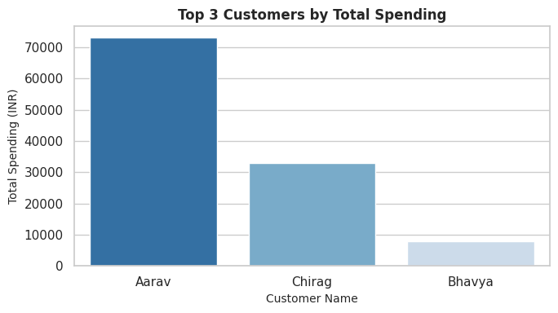

# Box Plot (Spending Distribution Across Genders) (Plot 6)
plt.figure(figsize=(6, 4))
# Added hue='gender' and legend=False to prevent FutureWarning
sns.boxplot(
data=merged_df, x='gender', y='amount', hue='gender', palette='Set2', legend=False
)
plt.title('Spending Distribution Across Genders', fontweight='bold')
plt.xlabel('Gender')
plt.ylabel('Purchase Amount (INR)')
plt.tight_layout()
plt.show()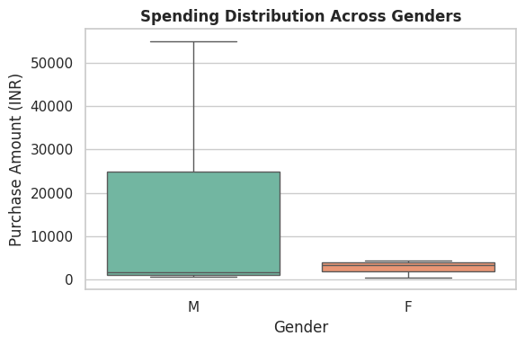
# Plot 7: Line Chart - Purchase date vs amount
plt.figure(figsize=(8, 4))
time_series = merged_df.sort_values('purchase_date')
plt.plot(
time_series['purchase_date'],
time_series['amount'],
marker='o',
linestyle='-',
color='purple',
)
plt.title('Purchase Amount Over Time', fontsize=12, fontweight='bold')
plt.xlabel('Purchase Date', fontsize=10)
plt.ylabel('Amount (INR)', fontsize=10)
plt.xticks(rotation=45)
plt.tight_layout()
plt.show()
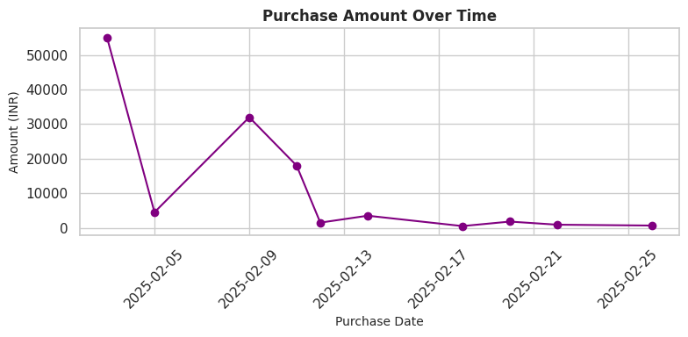

# Task 1.2: Monthly Sales & Growth Rate
months = [
'Jan',
'Feb',
'Mar',
'Apr',
'May',
'Jun',
'Jul',
'Aug',
'Sep',
'Oct',
'Nov',
'Dec',
]
sales = np.array([125, 138, 142, 155, 168, 180, 195, 210, 225, 240, 258, 275])
growth = np.diff(sales)
fig, ax1 = plt.subplots(figsize=(8, 4))
ax1.plot(months, sales, marker='o', color='teal', linewidth=2, label='Sales')
ax1.set_title('12-Month Sales Trend & MoM Growth', fontweight='bold')
ax1.set_ylabel('Sales (INR Thousands)', color='teal')
ax2 = ax1.twinx()
ax2.bar(months[1:], growth, alpha=0.3, color='orange', label='Growth')
ax2.set_ylabel('MoM Growth (INR Thousands)', color='darkorange')
ax2.grid(False)
plt.tight_layout()
plt.show()
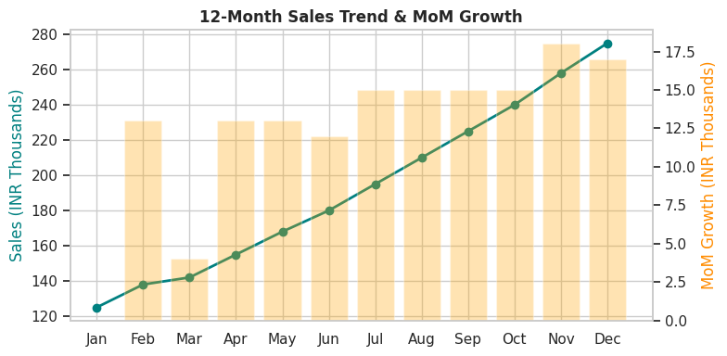
Data Analysis Conclusion
The exploratory analysis highlights significant revenue distribution across customer demographics and geography. Mumbai generated the highest total revenue (INR 73,000), driven primarily by high-ticket electronics purchases such as laptops and tablets. Aarav (C01) emerged as the most active and top-spending customer, contributing INR 73,000 across two transactions. Gender-based aggregation demonstrates that male customers spent significantly higher on average (INR 15,692.71) compared to female customers (INR 2,833.00), largely due to major consumer electronics investments. The timeline visualization illustrates distinct demand peaks corresponding to tech product purchases rather than uniform daily buying behavior. Strategic focus on high-value electronics and loyal repeat buyers presents the highest growth opportunity.
Costumer:
cust_id | name | city | age | gender
C01 | Aarav | mumbai | 28 | M
C02 | Bhavya | delhi | 32 | F
C03 | Chirag | bangalore | 26 | M
C04 | Diya | mumbai | NaN | F
C05 | Eshan | pune | 30 | M
C06 | Farah | delhi | 29 | F
C07 | Gaurav | bangalore | 40 | M
C08 | Hina | mumbai | 27 | NaN

Purchases:
purchase_id | cust_id | product | amount | purchase_date
P101 | C01 | Laptop | 55000 | 03-02-2025
P102 | C02 | Saree | 4500 | 05-02-2025
P103 | C03 | Smartphone | 32000 | 09-02-2025
P104 | C01 | Tablet | 18000 | 11-02-2025
P105 | C05 | Headphones | 1500 | 12-02-2025
P106 | C02 | Watch | 3500 | 14-02-2025
P107 | C06 | T-shirt | 499 | 18-02-2025
P108 | C07 | Backpack | 1800 | 20-02-2025
P109 | C03 | Mouse | 899 | 22-02-2025
P110 | C05 | Charger | 650 | 26-02-2025

Project links:
GitHub Link:
https://github.com/ayushkumar1311/E-Commerce-Customer-Insights-Spend-Analysis.git
Google collab: https://colab.research.google.com/drive/1JihOJy1sDSk9u-72a_rp0QzLw7YqH8DJ?usp=sharing

